Facebook

Definition
# Source: ScreenShots Source: Provided by: [Persons Table -> ID Column: 1, Name_En Column: Motasem Essam] -> Tool: [Lightshot Program] -> From [Site: https://web.facebook.com/] on [1/16/2026]
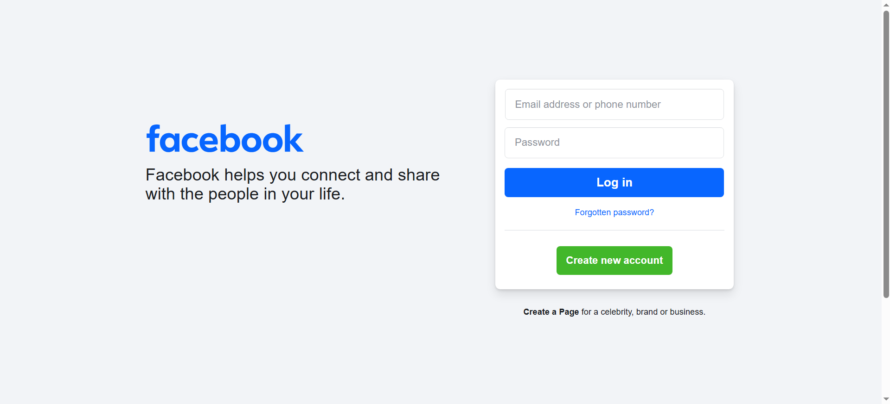
# Source: AI Source: Provided by: [Data Path: Persons Table -> ID Column: 1, Name_En Column: Motasem Essam] -> From: [ChatGPT] on [1/16/2026]
Facebook is a social media platform where people can connect, share content, and communicate online.
In simple terms, Facebook lets users:
- Create a personal profile
- Add friends and follow pages or public figures
- Post updates, photos, videos, and links
- Like, comment on, and share other people’s posts
- Message others privately (through Facebook Messenger)
- Join groups and events
- Use Marketplace to buy and sell items

Purpose
# Source: AI Source: Provided by: [Data Path: Persons Table -> ID Column: 1, Name_En Column: Motasem Essam] -> From: [ChatGPT] on [1/16/2026]
The purpose of Facebook is to connect people and help them share information and experiences online. It is designed to:
- Help users maintain relationships with friends, family, and communities
- Enable communication and self-expression through posts, photos, and videos
- Provide a platform for businesses, organizations, and creators to reach audiences
- Support community building through groups, events, and shared interests
- Allow access to news, entertainment, and marketplace services in one place

Background
# Source: AI Source: Provided by: [Data Path: Persons Table -> ID Column: 1, Name_En Column: Motasem Essam] -> From: [ChatGPT] on [1/16/2026]
- Launched in 2004 by Mark Zuckerberg and others
- Originally for college students, now used worldwide
- Owned by Meta Platforms, Inc., which also owns Instagram and WhatsApp

What people use it for
# Source: AI Source: Provided by: [Data Path: Persons Table -> ID Column: 1, Name_En Column: Motasem Essam] -> From: [ChatGPT] on [1/16/2026]
- Staying in touch with friends and family
- News and entertainment
- Business pages and advertising
- Community groups and events

